**Solenoids** are simple components that can be used for various applications. The name solenoid is derived from the Greek word “Solen” which means a channel or a pipe. Solenoids are used in both domestic and industrial equipment, they are available in various designs, each of them has their own specific applications. Although the application changes, their working principle always remains the same. Here we will discuss **Solenoid working and different types of Solenoids.**

**What is a Solenoid?**

A solenoid is a long piece of wire which is wound in the shape of a coil. When the electric current passes through the coil it creates a relatively uniform magnetic field inside the coil.

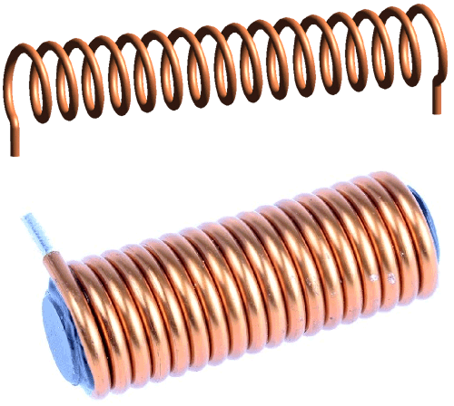

The solenoid can create a magnetic field from electric current and this magnetic field can be used to generate a linear motion with the help of a metal core. This simple device can be used as an electromagnet, as an inductor or as a miniature wireless receiving antenna in a circuit.

**Solenoid Working Principle**

The solenoid simply works on the principle of “electromagnetism”. When the current flow through the coil magnetic field is generated in it, if you place a **metal core** inside the coil the magnetic line of flux is concentrated on the core which increases the induction of the coil as compared to the air core.

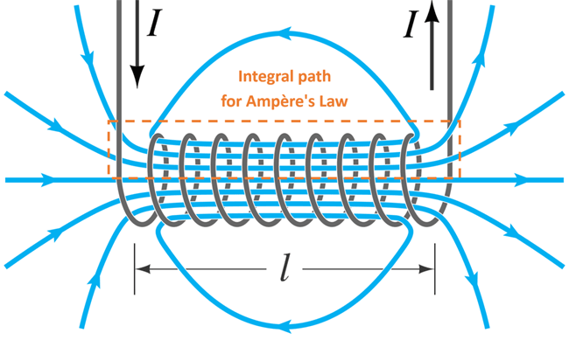

Most of the flux is concentrated only on the core, while some of the flux appears at the ends of the coil and a small amount of flux appears outside the coil.

The **magnetic strength of the solenoid** can be increased by increasing the density of the turns or by increasing the current flow in the coil.

Like all other magnets the activated solenoid has both Positive and Negative poles, through which an object can be attracted or repelled.

In this way, we can control the magnetic field of a coil by controlling and in turn use it for controlling the mechanical movement of metalcore.

The formula for the magnetic field in a solenoid is:

# **B=µIN/L**

**where B= Magnetic field**

**µ= Permeability**

**N = number of turns**

**I = current of coil**

**L= length of coil**

**Turns density, n= N/L (Number of turns per unit length)**

So from this formula, we can see that to increase the magnetic force produced in a solenoid coil, we will have to increase the number of turns, N and the current, I.

**Types of Solenoids**

There are different types of solenoids available in the market, the classification is made based on material, Design, and function.

* AC- Laminated Solenoid
* DC- C Frame Solenoid
* DC- D Frame Solenoid
* Linear Solenoid
* Rotary Solenoid

**AC Laminated Solenoid**

The AC laminated Solenoid consists of a metal core and a coil of wire.  The core is constructed with a laminated metal to reduce the stray current, this helps in improving the performance of the solenoid.

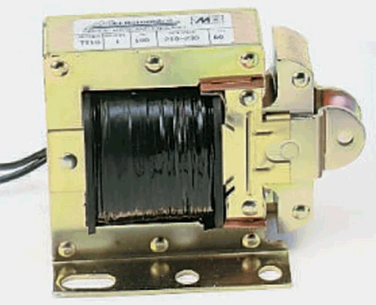

An AC solenoid has a special advantage because it can deliver a large amount of force in the first stroke. This is because they have an inrush current (An instantaneous high input current drawn by a power supply or electrical equipment when turn-on). They can use more strokes than a DC laminated solenoid.

They are available in different configurations and ranges, and they produce a clean buzzing sound when they are in operation.

An **AC Laminated solenoid can be used** in a variety of equipment’s that require immediate action, such as medical equipment’s, locks, vehicles, industrial equipment’s, printers, and in some of the household Appliances.

**DC C-Frame Solenoid**

The C frame refers to the design of the solenoid. The DC C-Frame solenoid has only a frame in the shape of the letter C which is covered around the coil.

The DC C-Frame solenoid is used in multiple day to day applications because of it more controlled stroke operation. Although it is said to be DC configuration, they can also be used in equipment’s designed for AC power.

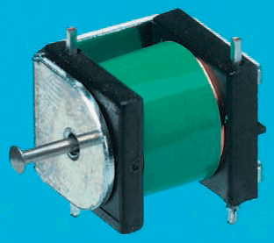

**This type of solenoid is mainly used** in gaming machines, Photographic shutters, Scanners, Circuit breakers, Coin counters and Bill changers.

**DC D-Frame Solenoid**

This type of solenoid has a two-piece frame covering the coils. They have similar function like a C-frame solenoid hence the D-frame can also be used with AC power and has a controlled stroke operation.

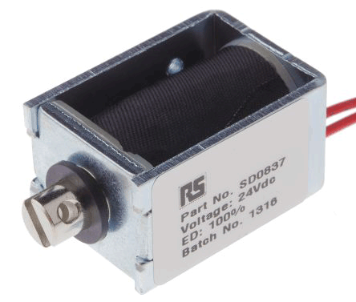

The **DC D-frame solenoid is used** for both conventional and medical applications such as gaming machines, ATM machines and Blood and gas Analyzer.

**Linear Solenoid**

Linear solenoids are more familiar among the people. It consists of a coil of wire which is wrapped around a movable metal core which helps us to apply pulling or pushing force to a mechanical device.

This type of solenoid is mostly used on starting devices. This switching mechanism helps in completing a circuit and allows the current to flow through a mechanism.

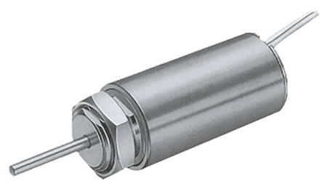

Linear **solenoids are especially used** in the automation and highly secured door mechanisms and starter motors of cars & bikes.

**Rotary Solenoid**

A rotary solenoid is a unique type of solenoid which is used for various applications where there is a need for easy automatic control process. It works on the same principle as the other solenoids and has the same elements, a coil, and a core, but they have a different operation.

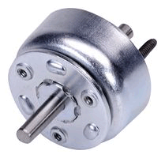

The metal core is mounted to a disk and has small grooves under it, the size of the grooves exactly matches the slots in the body of the solenoid. It also has ball bearings to make easy motion.

When the solenoid gets triggered, the core is drawn into the body of the solenoid and the disc core starts rotating. This setup will have a spring place in between the core and the body of the solenoid. Once the power supply is detached the spring pushes the disk core to its original position.

The **rotary solenoid is more robust** when compared to all other types of solenoids. They were originally designed only for the defence mechanisms, but nowadays you will be able to find them in many automated industrial mechanisms such as lasers and shutters.

**Conclusion**

Now you know about the **solenoids, working principle and the different types of solenoids** available in the market. The solenoids are the simple and effective solution for controlling the valves and electromagnetic switches or mechanical interlocks.

Their operation principle and instantaneous response made them a better solution for applications that need a large amount of power into a small space and where there is a need for quick, consistent, and robust operation.

<https://www.electronicsforu.com/technology-trends/learn-electronics/solenoid-basics-working>

<https://circuitdigest.com/article/what-is-solenoid-its-working-principle-and-types>